Welcome Students

Cuyamaca College – Fall 2018
Course Syllabus

Course: ESL 50 – 2868 Basic Accelerated Reading and Writing for ESL
Instructor: Dr. Noha Ireiqat
Days: Tuesday and Thursday
Time: 9:30 AM to 12:20 PM
Room: Building F, Room 608
E-mail: noha.ireiqat@gcccd.edu
Web site: https://www.cuyamaca.edu/people/noha-ireiqat/
Text & Materials:
Required Texts:
ESL 50 Student Activity Packet
Same Sun Here
Candlewick Press

ISBN 978-0-7636-6451-0

Catalog Description
This is the literacy course in the first level of the ESL accelerated course sequence. Students learn to read and write Basic English. They also learn basic word, phrase, and sentence grammar in a Just-In-Time remediation setting. In addition to reading, writing, and grammar, students learn classroom rules and communication necessary in academic settings. The course is designed to expose the students to all the skills necessary to enter a placement of four semesters below transfer level (ESL 1A), with the possibility of advancing in as little as two further semesters given the acceleration pathway. Pass/No Pass only. Non-degree applicable.

Pre-requisites:
Grade of “Pass” in ESL 070 or equivalent or assessment into ESL 50, ESL 70 or 80

Additional Information:
Must be concurrently enrolled in ESL 50G, and ESL 10 or ESL 99A

Course Content
- Reading skills content include materials to facilitate comprehension of basic passages with familiar content and language, grammatically complex readings of a beginning-intermediate to advanced-beginning level, and readings on unfamiliar topics.
- Writing skills include materials to facilitate in creating well organized basic English paragraphs with topic sentences, basic supporting details and some transitions; development of the writing process: pre-writing, writing, peer reviewing, revising and editing–all on a beginning intermediate level.
- Other skills content include activities to develop comprehension of simple grammar structures, a familiarity of academic topics, summary skills, an understanding of cultural and historical references, and vocabulary development through contextual and structural clues as well as reading strategies to develop speed and accuracy.

Course Objectives
Students will use an accelerated approach of intensified in-class and homework assignments, and at the end of the course they will be able to display the following skills:
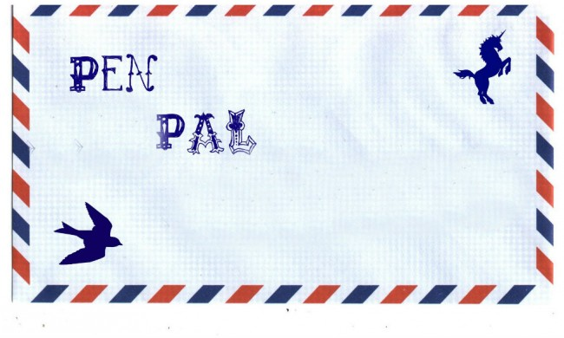
- Apply the rules for the formation, meaning and use of English structures when reading and writing in English.
- Read passages efficiently by applying appropriate reading strategies and understand common cultural references in text.
- Demonstrate a high intermediate level ability to read texts of some conceptual or linguistic complexity in an academic setting.
- Define new vocabulary based on reading and discussion, structural analysis and contextual clues.
- Use reading techniques to distinguish facts and details from opinions, judgments and conclusions.
- Use Basic English to communicate intended ideas.
- Use writing techniques to compose original paragraphs and multi-paragraph compositions, which display evidence of proper organization and development at a higher intermediate level with use of topic sentences and a thesis statement.
- Edit and proofread their own writing or peer writing at a high intermediate level following the basic rules of paragraph formation, essay structure, spelling, grammar and punctuation.

Exit Skills
Students having successfully completed this course exit with the following skills, competencies and/or knowledge:
- Apply basic punctuation and capitalization rules in writing with some errors.
- Write short paragraphs using the correct format that show an understanding of topic sentences and supporting sentences.
- Accurately identify the main idea in basic and some low-intermediate level readings using skimming and scanning techniques; distinguish between opinion and fact through contextual clues; and be able to discuss or write about reading topics.
- Deduce the meaning of words in basic and some low-intermediate level readings and apply new vocabulary in writing and speaking.
- Have some developed usage of adjectives, prepositions, articles and nouns in reading and writing.
- Have some developed punctuation rule usage in writing including commas, apostrophes and end punctuation.

Student Learning Outcomes
Upon successful completion of this course, students will be able to:
- Demonstrate understanding of high beginning to low-intermediate college level texts by being able to write an accurate summary and a response displaying critical thinking regarding this level of text.
- Produce a well-structured basic paragraph with a clear topic, good development, and relevant conclusion. Often or less errors in each category of the well-structured paragraph as defined in the preceding sentence shall constitute success.

Course Requirements:
All assignments must be turned in on time – no late work is accepted.

Vocabulary Worksheets
You will be assigned to remember the meanings and usage of a few vocabulary words for every reading. These worksheets must be turned in on time to Canvas.

New Vocabulary Log
You will be assigned to find new words and write the word with the complete sentence you found. Then, guess the meaning. One vocabulary log per unit of the book must be turned in on time to Canvas.

Journals
See your calendar for the dates they are assigned and make sure to bring a BLUE BOOK to class on those dates. A journal consists of writing your response to a special question the instructor gives you on that day.

Homework
You will have several homework assignments that include short writings in preparation for longer paragraphs and essays.

In-class Writing Exams
Following the dates that your first paragraph is due, you will be given a writing exam to be completed in class.

Annotation Checks
At different times during the semester the instructor may elect to check your books for the required annotations. Those who annotate get points. Those who don’t, don’t!

Tutor Visits
Three times during the semester you will be required to visit a tutor in the writing lab in order to seek help with one of your writing projects. You will turn in your tutoring slip to receive credit.

Canvas:
You will find the following exercises on Canvas. Be prepared to navigate this important utility both from school and from your home. If you do not own a computer, you may utilize the computer labs at school to complete the assignments.

Summary and Annotations Logs
You will summarize and comment on each reading assigned in the text. The purpose of these logs is to help you remember important details, which will be useful to you in preparation for exams and writing assignments. I will check the logs weekly during the semester to assign points. In order to get the full points for this assignment, you will need to briefly summarize the reading in your own words, and provide samples of annotation notes you made in the book.

Writing Checks
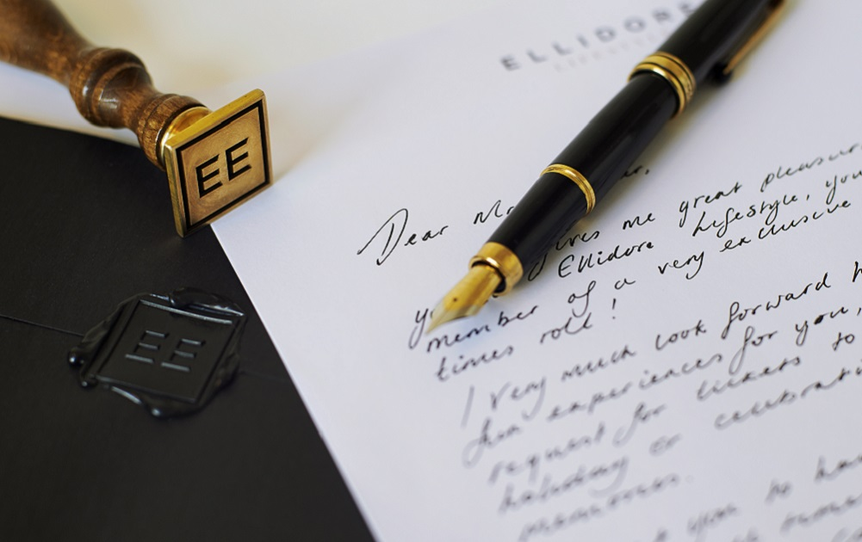
These are short quizzes about the different types of writings we are doing during the semester.

Vocabulary Quizzes
May consist of multiple-choice, fill in the blank, matching, true/false questions, complete sentences and short paragraphs.

Paragraphs
You will be expected to write 4 full paragraphs following MLA format. Two paragraphs are turned into Canvas on the Safe Assign feature, and two in-class paragraphs, one for the mid-term and the other as a final.

Group Discussions on Canvas
You are automatically assigned to a Group at the beginning of the semester. After each assigned reading, you will answer either a question from the instructor or from one of your group members on the Group discussion Board, as well as provide a question yourself for your fellow group members.

Grading:
Grading is on a point system.
Vocabulary Quizzes [5 Quizzes @ 5 pts] (Canvas) | 25 points
Journals [8 journals @ 5 pts] (Blue book) | 40 points
S and A Logs [12 Logs @ 5 pts] (Canvas) | 60 points
Writing Checks quiz [3 Checks @ 5 pts] (Canvas) | 15 points
Vocabulary Worksheets [5 sheets @ 5 pts] Canvas) | 25 points
New Vocabulary Log (12 sheets @ 5 pts) (Canvas) | 60 points
Homework [multiple assignments] | 30 points
Group Discussion [12 Discussions @ 5 pts] (Canvas) | 60 points
Annotation Checks [3 Checks @ 5 pts] | 15 points
Tutor Visits [3 Visits @ 5 pts] | 15 points
Paragraph 1 (Canvas) | 25 points
In-class Writing Exam 1 | 50 points
Paragraph 2 (Canvas) | 50 points
In-class Writing Exam 2 | 100 points
Total | 570 points

Final Grades:
513-570 | P | A
456-512 | P | B
399-455 | P | P
342-398 | NP | D
0-341 | NP | F

WARNING: THE INSTRUCTOR RESERVES THE RIGHT TO CHANGE ANY OF THE ASSIGNMENT POINT VALUES THROUGHOUT THE SEMESTER IF CIRCUMSTANCES WARRANT. THE INSTRUCTOR WILL INFORM THE STUDENTS OF THE CHANGE IF THIS OCCURS.

Writing Center (B-167, 660-4463)
To help you succeed in this class, sign up for Supervised Writing tutoring at the Writing Center. All tutoring sections are FREE. Tutors can assist you in analyzing sentence and paragraph structure to improve your overall writing skills, and your grade!

Student Responsibilities:
- Come to class on time and participate actively in class.
- Be responsible for all class work, homework assignments and announcements.
- Spend at least 12 hours every week doing homework for this class.
- Plan for more time to study and do homework (for example, family or roommates can help with children and/or with food preparation, so that YOU can study).
- Attend the final exam (DEC. 11th 9:30-11:30 AM).
- Schedule appointments (doctor, EOPS, driving tests, etc.) before or after class.
- Turn off all cell phones (and other electronic devices) while in class. DO NOT text message. You can use your mobile phone to access dictionaries, but keep your phone silent.
- Every hour of class time you will be given a 10-minute break. Please DO NOT leave the classroom during class time. Wait until you have a break to leave the classroom.
- DO NOT CHEAT. Do your own work on the e-book homework and tests. Students who cheat or allow other students to cheat will get no credit for that assignment or test. Continuous cheating will result in NO CREDIT for the class.
- Show respect for the teacher and other students. DO NOT make negative comments about other people's religions, race, gender, sexual orientation, disabilities, appearance, nationality, language, age, etc.
- DO NOT interrupt others while the teacher or another student is talking.
- For your own benefit as an ESL student, USE ENGLISH in the classroom.

Disruptive Behaviors:
Disruptive behavior interrupts the classroom and disturbs the teaching and learning process.
The following is considered disruptive behavior:
- Using cell phones, text messaging, iPhones, or loud electronic devices in class.
- Coming in and out of class frequently during class time without permission.
- Coming late and leaving the class early.
- Interrupting the teacher or another student who is talking. Giving answers for other students while they are thinking their answers.
- Correcting other student’s answers.
- Talking to other students while the class is in a large group format.
- Asking other students for translation or help to give answers when called on in class.
- Showing anger, arguing, and demanding immediate attention to questions about tests, grades or individual needs.
- Making disrespectful comments about religion, race, language, appearance, gender, sexual orientation, disabilities, nationality, etc.

Cheating.
Includes:
- Copying homework, answers, or other student’s assignments
- Giving other students answers
- Copying ideas from the Internet or from books without giving credit to the source
- Offering bribes in exchange of a passing grade

During exams and or quizzes doing any of the following:
- Talking about anything
- Looking at another student's paper
- Looking at notes on a desk, paper, in a book, or any other place
- Not returning papers to the teacher when the time has finished
- Using your mobile cell phone. You must not use your mobile cell phone during exams for any reason. Turn it off

Consequences for Disruptive Behavior:

If a student does any of the disruptive behaviors described above, the student will be disciplined. The following are the steps in the discipline process:
- The teacher will inform the student of what he/she has done. If it is not serious, the teacher will talk with the student. If it is serious, the teacher will refer the student to the Dean of Student affairs.
- For a second offense, the teacher will refer the student to the Dean of Student Affairs, and the teacher can suspend the student.
- If the teacher suspends the student, the student must miss two (2) class periods before attending class again.
- If a student has too many absences (more than 3), the teacher may drop the student from the class. (See Attendance above)
- Cheating may result in getting “0” points for a test, quiz, or homework.
- If a student continues to cheat, the student may receive NO CREDIT (NC) for the class.

This course adheres to the policies and procedures listed in the college catalog.

Important Dates throughout the Course:
Regular Day & Evening Classes Begin | August 20
Last Day to Drop without "W" (semester length classes) | August 31
Last Day to Apply for Refund (semester length classes) | August 31
Holiday (Labor Day) | September 3*
Last Day to Drop Semester Length Classes | November 9
Holiday (Veterans' Day Observed) | November 12 (Monday)*
Holiday (Thanksgiving) | November 22, 23, 24*
Final Examinations | December 11th 9:30 to 11:20 AM

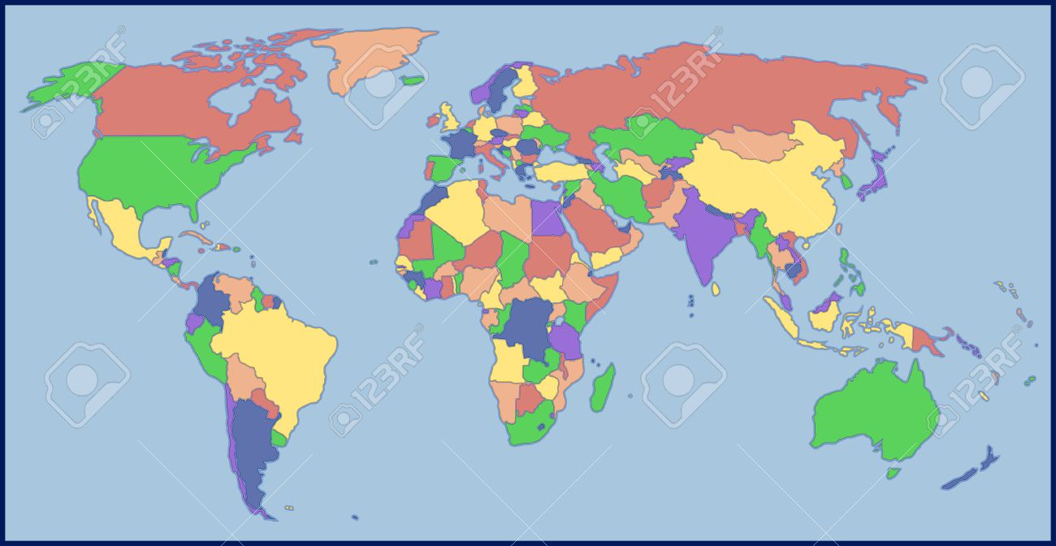

Attendance: Being in class is very important because students bring a great deal of experience from their lives and culture, and we need your participation! Additionally, students who attend class regularly, answer questions, work in groups, and come prepared (always bring your books, paper, and pen or pencil) may receive bonus points towards their grade. If you are late arriving to class by more than 15 minutes, it will count as a tardy. 2 tardies = 1 absence. If you are absent for more than 4 days, you will be dropped!!!

If you cannot come to class, make sure you have someone you can call to find out what material was covered, so you can be prepared for the next class.

__________________________________________________________________________________
Student Name Telephone #

__________________________________________________________________________________
Student Name Telephone #

Plagiarism
A zero tolerance policy for cheating or plagiarism!

According to the Cuyamaca College Catalog, Student Code of Conduct, Academic Dishonesty such as cheating or plagiarizing, is grounds for instructional and administrative sanctions. That means that if you present the words (even three or more in a row), ideas, or work of someone else as your own, or if you have your work heavily rewritten by someone else and turn it in as your own, your instructor has the right to fail the assignment. The same is true if you are seen or otherwise caught cheating on a quiz, exam or other non-collaborative assignment. In addition to whatever penalty the instructor applies to your graded work, he/she will report your misconduct to the Department Chair, the Instructional Dean and the Associate Dean of Student Affairs. The Associated Dean of Student Affairs will keep a master list of cases of student misconduct. Any student who is reported to have cheated or plagiarized twice will be called in for a meeting with that dean. It will be up to the dean's discretion to determine what action to take, but students may be SUSPENDED FROM THE COLLEGE OR PERMANENTLY EXPELLED for repeated acts of cheating or plagiarism. Please feel free to consult the college catalog for further information or visit http://www.cuyamaca.edu/ascc/conduct.asp

Students with disabilities who may need academic accommodations should discuss options with their instructors during the first two weeks of class. It is also recommended that you contact Disabled Students’ Programs & Services (DSP&S) in A-114. You may also call DSP&S at 660-4576 to schedule an appointment.

Weekly Schedule for ESL 50

Day & Date | In-Class Activity | Homework | Topics
Week 1  T & TH  8/21 & 8/23 | Introduction to class and packet pre-reading. Packet 1. Activity 1A and 1B | Read Same Sun Here unit 1 pages 1-23 | Part I. The Characters
 | Packet 1. Activity 2 Explain Vocabulary logs | Read Same Sun Here unit 1 pages 1-23
Week 2  T & TH  8/28 & 8/30 | Packet 1. Activity 3 (first writing)  Activity 4 (vocab 1)  Explain summary and annotation logs | S and A log #1 (unit 1 pages 1-23) due week 3.  Journal 1 due week 3  Vocabulary worksheet 1 due week 3 | Identity (cultural, national, gender)  Names and their meanings.
 | Packet 1. Activity 5  Discussion Journal 1 | Vocabulary Log 1 due week 3  Discussion 1 by week 3  Vocabulary quiz 1 due week 3
Week 3  T & TH  9/4 & 9/6 | Packet 1. Activity 6 (vocab 2) and Activity 7 | S and A log #2 (unit 2 pages 24-53) due week 4 Vocabulary worksheet 2 due week 4, | Geography  Poetry
 |  | Vocabulary worksheet 2 due week 4, Vocabulary quiz 1 due now, Vocabulary Log 2 due week 4 Discussion 2 due week 4
Week 4  T & TH  9/11 & 9/13 | Packet 1. Activity and activity 8 | S and A log #3 (unit 3 pages 54-73) due week 5  Discussion 3 due week 5 | Mountaintop removal  What does it mean mountains and cities have moods?
 | Packet 1. Activity and activity 9  Character development poster session | Journal 2 due week 5  Vocabulary quiz 2 due
Week 5  T & TH  9/18 & 9/20 | Packet 1. Activity 10  Lecture on the perfect paragraph  MLA Format  Topic sentence development | S and A log #4 (unit 4 pages 75-101) due week 6 | Fighting for nature
 | Packet 1. Activity 11 and 12 (vocab 3)  Support sentence development  Class survey | Tutor visit 1 due week 6  Vocabulary Log 3 due week 6  Discussion 4 week 6
Week 6  T & TH  9/25 & 9/ 27 | Packet 1. Activity 13 | S and log #5 (unit 5 pages 102-130) due week 7 | Obama, US elections, Thanksgiving
 | Packet 1. Activity 14. | Vocabulary quiz 3 due  Vocabulary Log 5 and 6 due week 7  Discussion 5 and 6 week 7
Week 7  T & TH  10/2 & 10/ 4 | Packet 1 Activity 15 | S and A log #6 (unit 6 pages 131-151) due week 8  Writing checks quiz 1 due week 8 | Death and activism  Grandmothers
 | Packet 1 Activity 16 | Vocabulary Log 7 due week 8  Discussion 7 week 8 | Part II. Issues
Week 8  T & TH  10/9 & 10/11 | Packet 1 Activity 17 | S and A log #7 (unit 7 pages 152-175) due week 9  Journal 3 due week 9 | Growing up and gender issues. Writing what is in your mind.
 | Discussion of first paragraph. Discussion of Part II of the course relating to social concerns and issues found on the reading. | Discussion 8 due week 9  Paragraph #1 due on Canvas week 9
Week 9  T & TH  10/16 & 10/18 | In class paragraph—Midterm  Annotation check #1 | S and A log #8 (unit 8 pages 176-202) due week 10  Journal 4 due week 10 | Christmas in New York and Kentucky.  Tragedy in Kentucky.  Generalizations – stereotypes
 | Packet 2. Activity 1 | Discussion 9 due week 10
Week 10  T & TH  10/23 & 10/25 | Packet 2. Activity 2 (vocab 4) and Activity 3 | S and A log #9 (unit 9 pages 203-224) due week 11  Tutor visit 2 due week 11 | Birthdays  Racism and hillbillies
 | Packet 2 Activity 4 | Paragraph #2 due week 11 on Canvass.  Discussion 10 due week 11
Week 11  T & TH  10/30 & 11/1 | Packet 2 Activity 5 | S and A log #10 (unit 10 pages 225-242) due week 12.  Journal 5 due week 12  Vocabulary quiz 4 due | Protest, civil, labor, community rights  Civil disobedience
 | Packet 2 Activity 6 and 7 (vocab 5) | Discussion 11 due week 12
Week 12  T & TH  11/6 & 11/8 | Packet 2 Activity 8  Annotation check #2
 | Packet 2 Activity 9 | S and A log #11 (unit 11 pages 243-265) due week 13.  Journal 6 due week 13  Vocabulary Log 12 due week 13  Discussion 12 due week 13 | Time magazine, national exposure
Week 12  T & TH  11/6 & 11/8 | Packet 2. Activity 10
 |  | S and A log #12 (unit 12 pages 266-297) due week 14.  Journal 7 due week 14. | Citizenship and meeting at last
Week 14  T & TH  11/20 & 11/22 | Packet 2. Activity 11 | Journal 8 due week 15.  Writing checks quiz 3 due week 15  Tutor visit 3 due week 15
 | Holiday  Thanksgiving | First draft of final paragraph due week 15
Week 15  T & TH  11/27 & 11/29 | Activity 12 | First draft review
 | Activity 13 | Final draft of final paragraph #3 due on Canvass by end of week 16
Week 16  T & TH  12/4 & 12/6 | Activity 14
Prepare for final exam
Annotation check 2

Final Exam
12/11/2018
9:30 a.m.-11:20 a.m.
In-class paragraph #2

*Note: This course schedule is subject to change – if so, you will be notified.

Have a great winter break!

