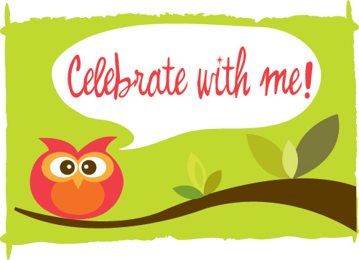

My child will be celebrating ___________________________
(Name) (Event)

on . I_____________________________ would like to celebrate in the classroom
(Date) (Parent/Guardian)

by bringing the following:

Please check the one item listed below that you will be bringing:
Fruit Popsicles
Fresh Fruit
Yogurt or Go-Gurts
String Cheese or cheese cubes with apples or other fruit
Vegetables and dip (be careful of nut exposure)

Please discuss your celebration request with your classroom Lead Teacher before completing this form. Turn in the completed form to the Front Desk for review and approval by the Front Desk/Coordinator.
Please submit no less than ONE WEEK in advance of any approved celebration.

Supervising Teacher’s Approval _______________________________________Date _________________
Front Desk Notified_________________________________________________ Date__________________

Cuyamaca College Child Development Center Celebration Policy
Celebrations often play an important role in the lives of children and their families. We welcome the opportunity to collaborate with families in sharing meaningful celebrations that are complementary to our daily programs. This policy is meant to provide opportunities for children and families to share their cultural traditions and celebrations with their peers in the classroom.

Prior Approval –
- Prior approval for any in classroom celebration is required. Families are asked to talk directly with their Classroom Lead Teacher to discuss their interest and collaborate in making a plan for a celebration.
- Families must request at least one week in advance of any planned celebration to be held in the Center. Those who do not get prior approval will be turned away and asked to schedule their celebration at a later date.
- Snacks brought without prior approval will not be served.

Times – Celebrations will typically occur in your child’s classroom, generally between 10:00-10:30 , be sure to check with the teacher,

Food/Drink – The Center works hard to promote healthy eating for all children and this includes food choices for celebrations and events. Some food choices include: fruit that we serve infrequently during meals such as strawberries, watermelon, cantaloupe, grapes, berries, or a combination; fruit popsicles; yogurt/go-gurt; string cheese; veggies & dip or any food to dip is always a hit! All food and drink items must adhere to the CDC Food Policy, including the Nut-Free Policy.

Where to Sign-In Food for Special Celebrations or Events: Please sign in all food items at the Front Desk and notify them that the item is for a special event in your child’s classroom. If the food is perishable, please let them know that as well. Also notify the classroom teacher that food has been left at the Front Desk for the celebration.

No Homemade Treats – Due to the challenge of ensuring that homemade treats are completely nut free the Center must insist only items packaged with labels included “no nut exposure” are used within the Center. Cross contamination with utensils, ingredients and cooking surfaces are a potential hazard and hard to control in homemade treats.

Storage – Space is very limited in The Child Development Center kitchen so please keep this in mind when making food choices. If the food item you bring needs special storage, simply sign it in at the Front Desk and notify them that a perishable item has been left. Also notify your child’s teacher so that someone will be sure to come to the Front Desk to verify the items and place them in proper storage area. Be sure to discuss storage of your item(s) when planning for your event with the classroom Lead Teacher.

Inclusion – Please keep in mind, that we are aware that some children have certain food allergies. If a treat for snack time is brought in that your child cannot eat, the Center will provide the regularly scheduled snack for that day.

Candles/Toys, Presents, Trinkets, Goodie/Gift Bags – The CDC does not allow any candles. toys, presents, trinkets, or goodie/gift bags to be passed out to children for any celebrations or to be left in cubbies or art folders.

Other Ways to Celebrate – Families are encouraged to enjoy celebrations in ways other than food as well. This may include reading your child’s favorite book to their class on a special day, donating a favorite book or providing some other special item that the children in the Center would enjoy having in the classroom.

Checklist for Celebrations:
Choose a date to celebrate
Decide on food/drink-remember our NO NUTS POLICY!
Obtain prior approval in writing from Lead Teacher and front desk one week before the intended celebration
items to decide with the Lead Teacher:
- date and time
- food and drink
- storage/cooling requirements
- family member(s) attending – yes or no
Carefully check all food labels for nuts or cross-contamination of nuts.
Celebrate!!

